
Application form for free equipment for
‘Trap/Catch-Neuter-Return’

Conditions

- Please note that the value of the equipment donation is £250 inclusive of Customs duty, VAT, and shipping costs. Customs duty, VAT and shipping costs can vary greatly depending on which country the equipment is sent to. By far the cheapest option is to use a UK delivery address, otherwise we will investigate the cheapest option for you.
- If delivery to a UK address is not possible then SNIP International will ask you to place the equipment order with MDC yourself after your donation has been agreed. SNIP International, will arrange payment once the order has been processed. This is in order to avoid being charged for the VAT twice (in both countries).
- Please email the application to snipinternational@gmail.com
- Please send SNIP International photos of the equipment in use within 6 months using the email address above.
- We will send you a questionnaire to be filled in and returned after 12 months. Future requests for equipment will not be considered if the questionnaire is not returned.
- You hereby give SNIP International permission to use any text and photos in our publications and on our website and Facebook page.
- Please mention the donation on your website and Facebook page if you have one, and please include a link to the SNIP International site.
- All applications will be discussed by the Board of Trustees at their meetings, which are held approximately every three months.
- Only one application from a group will be considered in any 12 month period.

To apply

- Please fill in pages 2-4 and tick the equipment boxes you want to apply for.
- Please note that SNIPi does not donate nets or catchpoles unless you have received previous training on using them.
- Other equipment can also be requested. If you want to apply for something outside the selection shown below then please explain your needs for the item.
- Suppliers that we recommend are: MDC Exports www.mdcexports.co.uk
Metalcote www.metalcote.co.uk
Aces (USA) www.animal-care.com
Details of your organisation

N.B. Please print clearly!

You
- Your name:

- Your email address:

Your organisation

- Name of your organisation:

- Town:

- Country:

- Email address for your organisation:

- Telephone number for your organisation:

Details for delivery

- Name of person/organisation:

- Street:

- Town:

- Postal code:

- Country:

- Contact telephone number for delivery:

Please note!

Your organisation hereby agrees to send photos of the equipment donation in use within 6 months and to fill in and return the questionnaire within 12 months.

You hereby give SNIP International permission to use any text and photos in publications and on our website and social media.

Let us get to know you better!

- When was the organisation founded and how is the organisation recognised in your country ?

- Number of paid employees?

- Number of volunteers?

- Have any of your active members had any training in using trapping equipment, caring for or otherwise helping stray and feral cats and dogs? If yes, what training?

- What equipment do you already have ?

- How many animals and which species have you dealt with in the past 12 months ?

 | Cats | Dogs | Other | Comments
Trap/catch
Spay/neuter
Return/release
Rehome
Euthanasia
In a shelter

- Please explain your organisation’s policy on:

  - Spay/neuter:

  - Pregnant cats and dogs:

  - Euthanasia:

- Please explain what plans your organisation has for the next 12 months ?

Please tick the equipment you would like :

Gloves
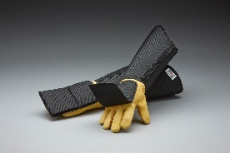 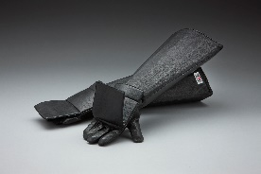 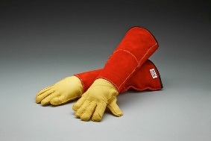
Rabies Bitemaster Ultra Bitemaster Animal
Gloves Gloves Handling Gauntlets
Mens ☐ Womens ☐ M ☐ L ☐ XL ☐ Mens ☐ Womens ☐
£67.50 £51.30 £58.50

Traps
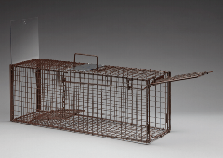 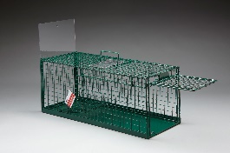 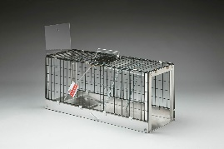 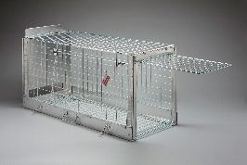
Eezicatch Cat Trap EeziCatch Cat Trap Foldaway Eeziset Vulcan Dog
Mesh Floor ☐ Solid Floor ☐ Cat Trap ☐ Trap ☐
L78cm x W23 x H30 L78cm x W30 x H30 50mm deep x L76.6 x W27 L1.3m x W52cm x H61cm
£49.10 £63.90 £87.75 £197.10

Trap Transfer restrainers and baskets
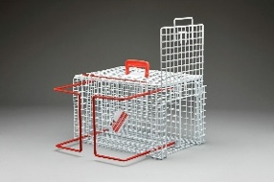 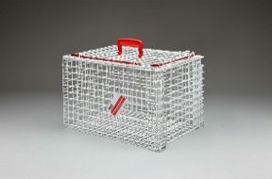 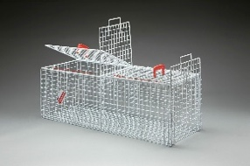
Trap Transfer Trap transfer Hospitalisation
Restrainer Trap ☐ Carrier ☐ Carrier Basket ☐

L46cm x W29cm x H29cm, 2.9kg L46cm x W29cm x H29cm, 3.1kg L102cm x W38 x 35cm, 5.5kg
£34.65 £29.25 £72.90

Nurses Best Friend

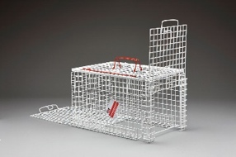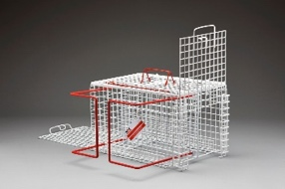
Nurses Best Friend Nurses Best Friend
Transfer ☐ Restrainer Plus ☐
L46cm x W30cm x H30cm, 3,1kg L46cm x W30cm x H30cm, 3,1kg
£53.72 £66.97

Other equipment requests
.
.
.

